Exhibit 3.1: Sketching / Paper Prototyping

# Sketch 1

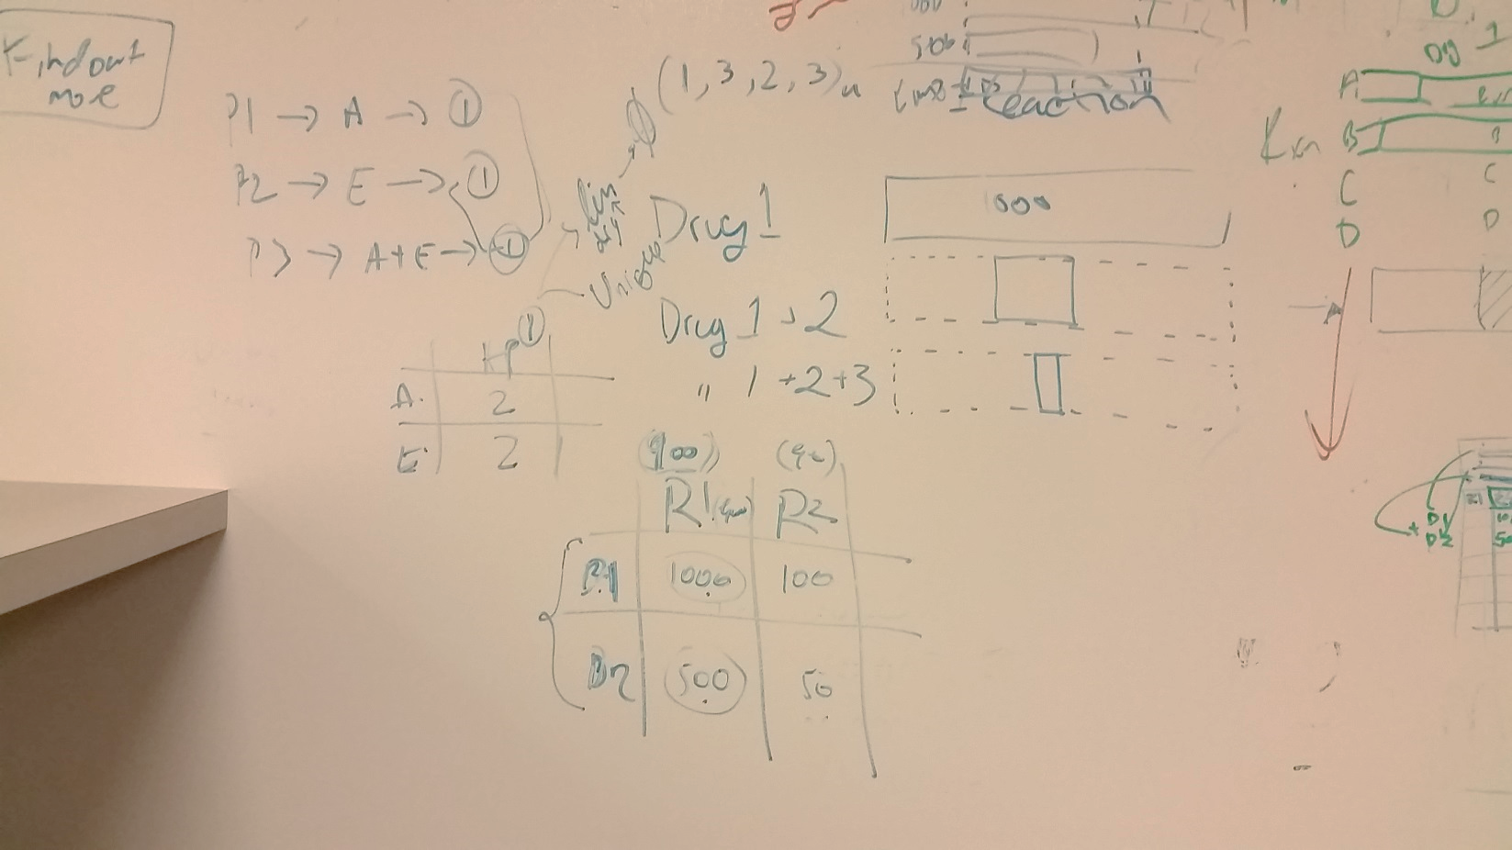

# Sketch 2

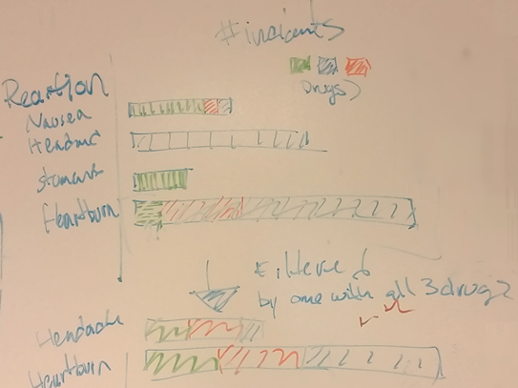

# Sketch 3

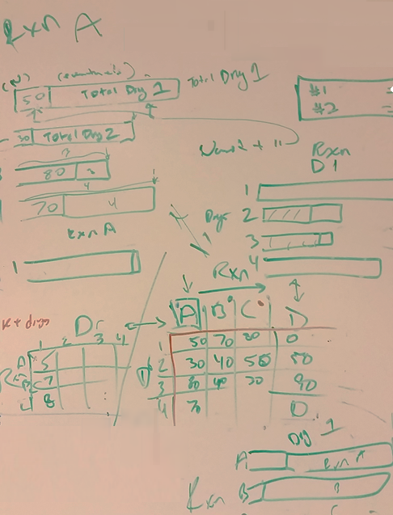

# Sketch 4

